Jadon Downs

ELEC 3800 – Project 5

04/12/2021

1. The sample mean of X is 1.5249
2. R (0.05n) for n = -50<X<50 according to Eq. 6-15

**MATLAB Code used to plot function**

t = 0.05;

m = mean(X)

xc = xcorr(X, 50, 'unbiased');

xb = xcorr(X, 50, 'biased');

plot([-50:50]*t,xc)

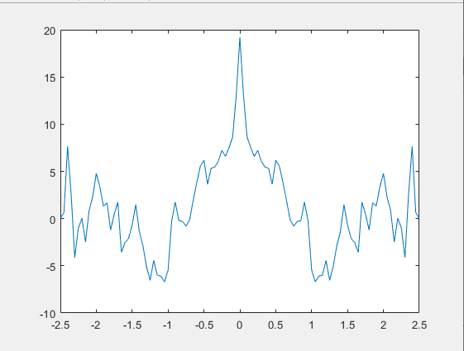

1. R (0.05n) for n = -50,….,50 according to Eq. 6-16

**MATLAB Code used to plot function**

t = 0.05;

m = mean(X)

xc = xcorr(X, 50, 'unbiased');

xb = xcorr(X, 50, 'biased');

plot([-50:50]*t,xc)

hold on

plot([-50:50]*t,xb)

